June 19, 2019

Re: Road Tender 2019-01 R21331 Blocks OZ4/MC4/MC5

The Barkley Community Forest sent out road tender packages to 4 companies by invitation and advertised the package
on the website for the public and other interested parties for the opportunity to bid.

The board received 4 packages and after review and approval the following list below is the rankings of the tenders:

- TCH Contracting Ltd
- Roc star Enterprises Ltd
- Denis Francoeur Backhoeing Ltd
- 0870849 BC Ltd

Yours truly,

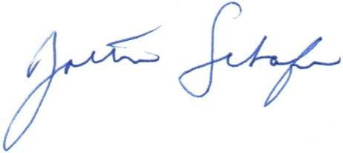
_______________________________
Zoltan Schafer R.P.F.
General Manager
BCFLP
zolie_schafer@telus.net
250-720-1177

